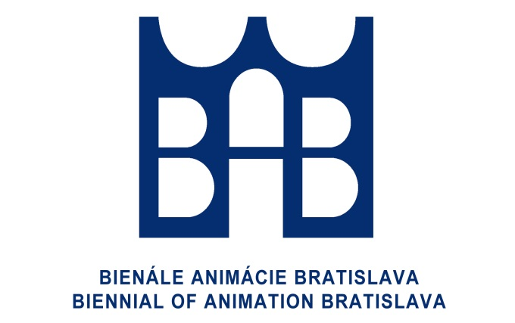

Press release
XIV. Biennial of Animation Bratislava
International Festival of Animated Films for Children
– BAB 2018

The International Festival of Animated Films for Children – Biennial of Animation Bratislava is organized by BIBIANA, International House of Art for Children and this year, it will take place from 8 October to 12 October. The first information was presented on 6 June at the pre-festival press conference at the Film and Television Faculty of the Academy of Performing Arts in Bratislava.
The intention of this conference was to activate and get the attention of elementary schools and media in the right time to inform them about this coming special cultural event that represents non-commercial culture for children and is a great device of education in the field of media. It also turned to secondary art schools to appeal for their cooperation with the expert festival events.
This year, festival brings some interesting information and novelties. First of all, it is its spread in different regions – Myjava joins Prešov, Prievidza and Košice. Like children in Bratislava, children in these cities will also have the opportunity to see not only the films taking part in the competition, but also very interesting collections of films. In cooperation with the organization Animánia from Pilsen in the Czech Republic, trainers-animators will visit the regions to open this creative media activity outside of the capital city. It can then continue even after the end of the event. It is very important that the BAB Festival has become a new member of the European Children´s Film Association in Brussels that has its independent international jury and gives the ECFA Award for the best European film.
There are 280 programmes from 50 countries taking part in the competition which brings, in comparison with last years, extraordinary geographical variety and almost a double number of participating countries. Application forms coming from big public-service televisions /NHK, ZDF, RAI, ČT/ as well as from our home television RTVS are a very positive signal and expression of trust to the BAB Festival.
The priority of the programme set by the organizers is to put emphasis on the profession of animators and there will be a separate exhibition in BIBIANA, which together with the collection of young Slovak animators introduces a playful and adventurous way of learning during the half century of its development. It does not forget to pay attention to the 25th anniversary of the Department of Animation at the Academy of Performing Arts.
Fairy-tale collections of films from abroad, Visegrad countries and Japan will remind us of the interconnection of variety of cultures, graphic and animation techniques that are joined together to bring the quality of non-commercial culture. Bratislava will become a really fairy-tale city for some days and during the festival time it will be visited by significant personalities and legends of animated film from abroad and Slovakia.
The importance of making films for children is supported by the Slovak Commission for UNESCO and the BAB festival takes place under its aegis. .

BIBIANA
International House of Art for Children
BAB Secretariat

